Các trang tham khảo:

1. https://nhataostore.com/

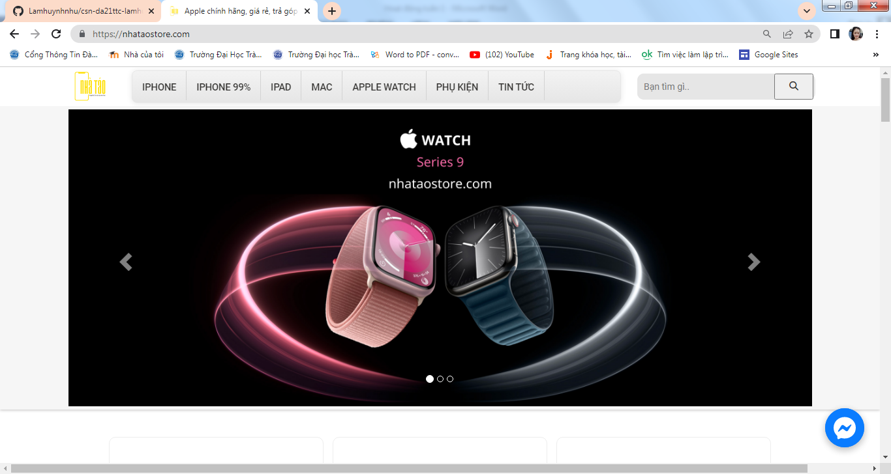

1. Tham khảo youtube: https://www.youtube.com/watch?v=fAAHMwa8Q1o&list=PLH88ngaKjRaTN9qhlrogRZaZqXMgYKgjiS

